**LETSUPGRADE LINUX ADMINSTRATION**

**DAY 6 ASSIGNMENT**

Question 1

1. Use ps to search for the “systemd” process by name.

2. Find out your terminal name.Using your terminal name, use ps to find all processes associated With your terminal.

3. Check and note the process id of your shell(from the output of the above command).

Also, note the parent process id of your shell.

4. Start 3 instances of “sleep 123” as background processes.

5. Check and note the process id’s of all sleep processes.

6. Display only those three sleep processes in top. Then quit top.

**ANS 1 .**

. Use ps to search for the “systemd” process by name.

**In my system the first process is init show it is not systemd:**

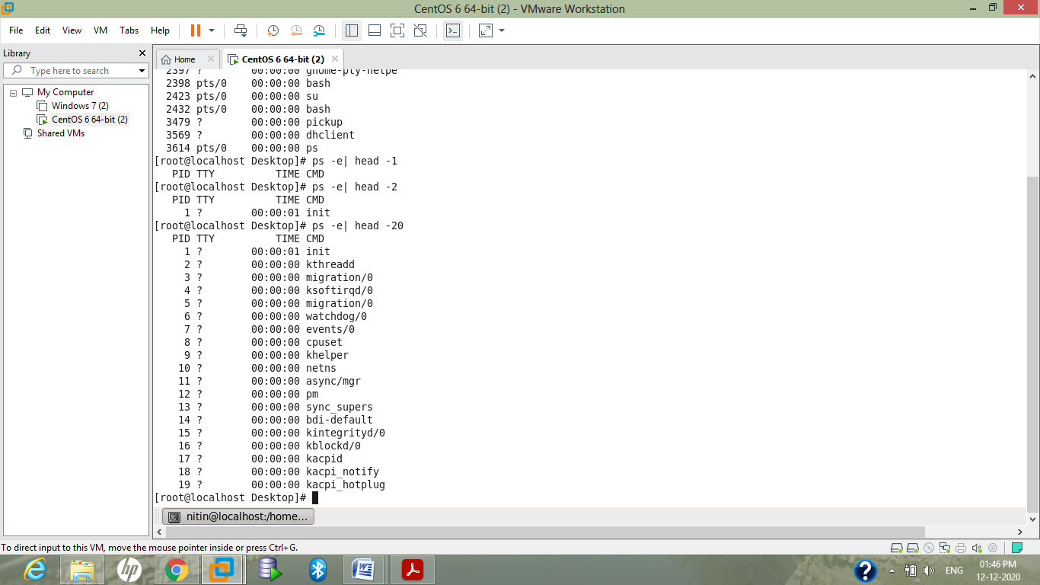

**for finding this by name :**

**ps -ef |grep init**

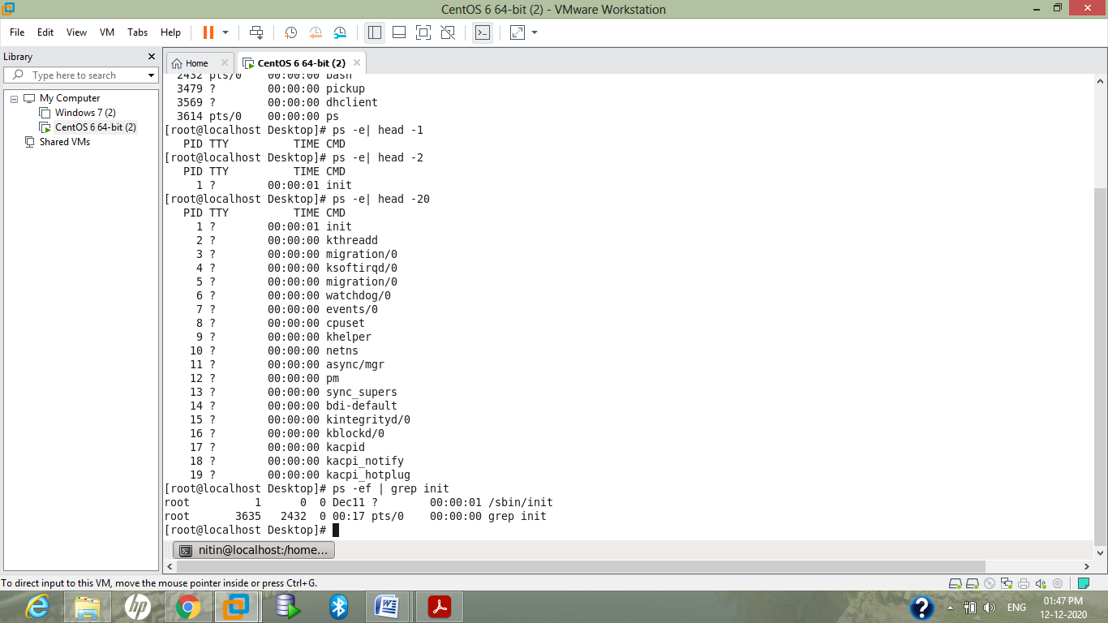

**for finding systemd process:**

**ps -ef |grep systemd**

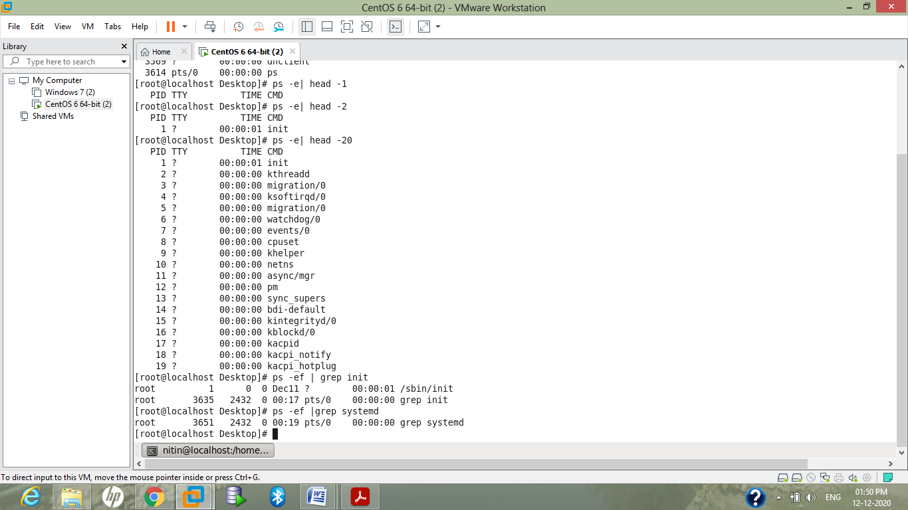

**ANS 2.**

. Find out your terminal name.Using your terminal name, use ps to find all processes associated With your terminal.

First finding terminal by using tty comand:

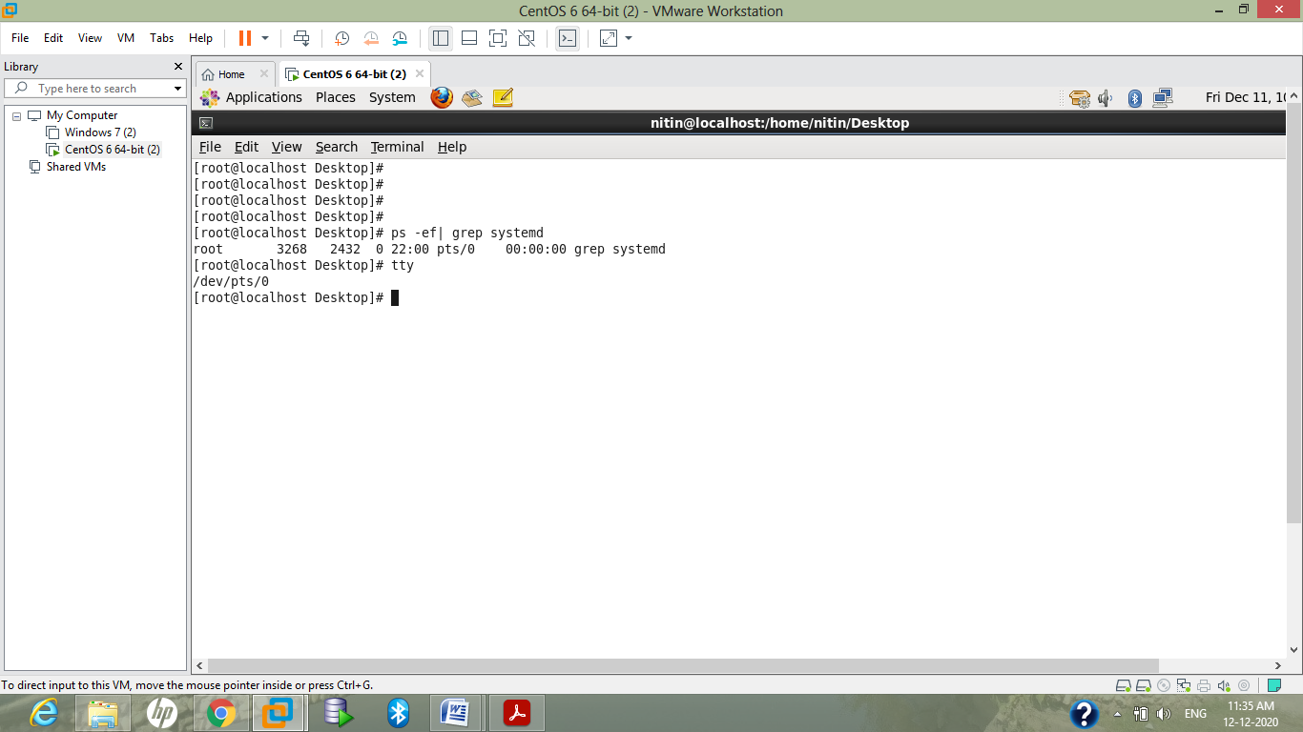

**Finding all processes associated with it:**

**ps -t /dev/pts/0**

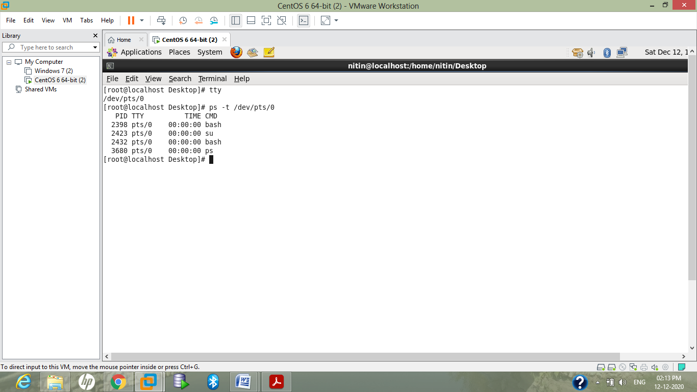

**ANS 3.**

**Here process id of our shell is 2432 and Parent process id is 2398**

**ANS 4.**

Start 3 instances of “sleep 123” as background processes:

command : sleep 123 &

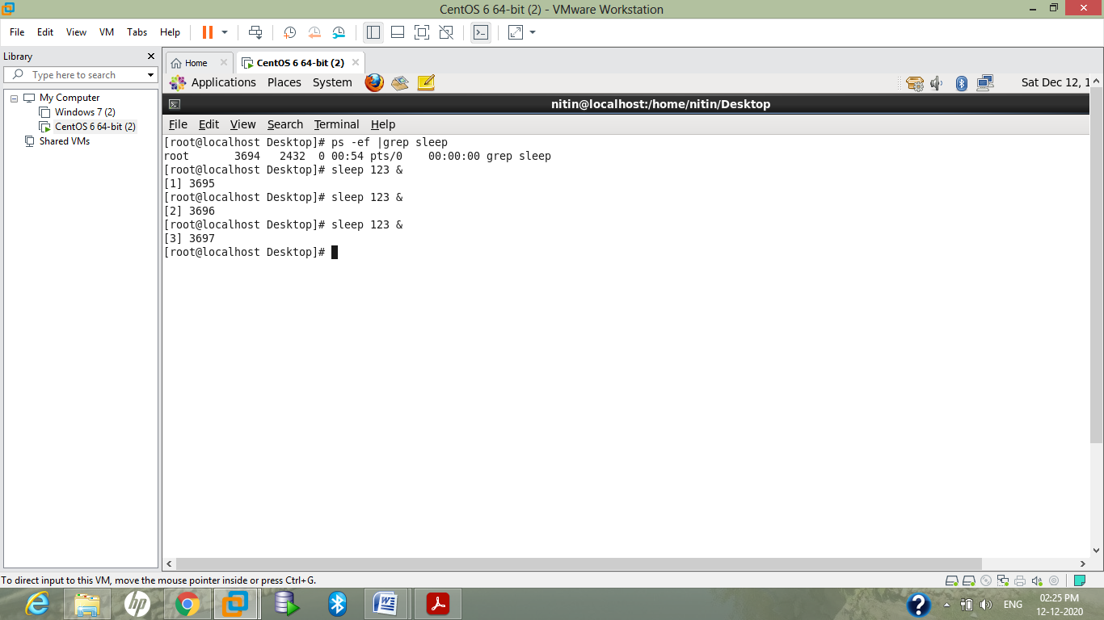

**ANS 5.**

**checking all 3 sleep process:**

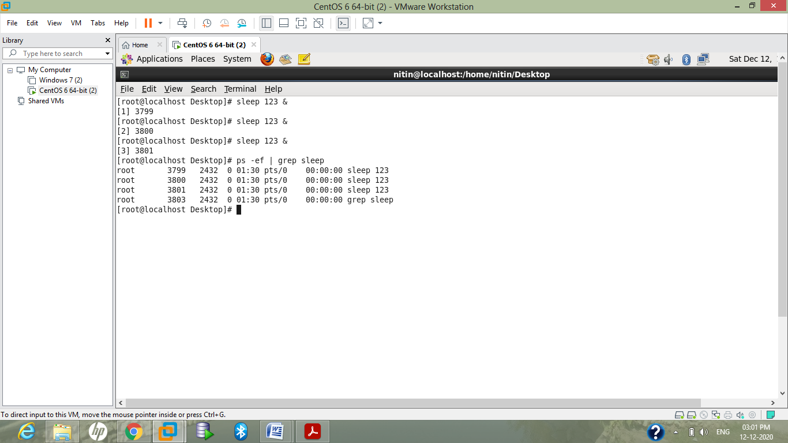

**process id of these three sleep processes are 3799,3800,3801**

**ANS 6.**

**Displaying only these three sleep process**

**by Top command:**

**top -p 3799,3800,3801**

